How to start MecwaysAsterBridge

- Go to: Download Code_Aster and Salome-Meca – SimulEase
- Download the 2025 version from Code_aster for Windows: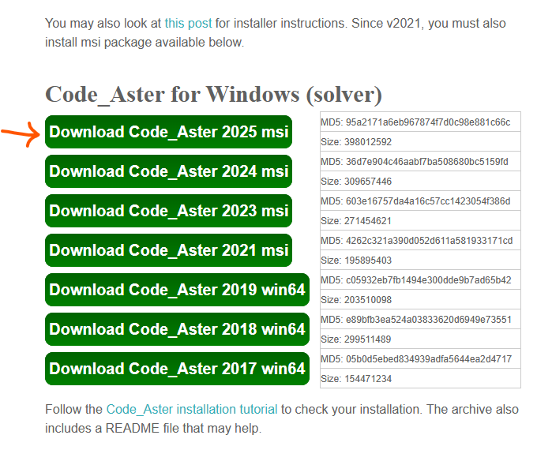
- Install Code_Aster for Windows
- Open Mecway and go to Tools/Scripts:
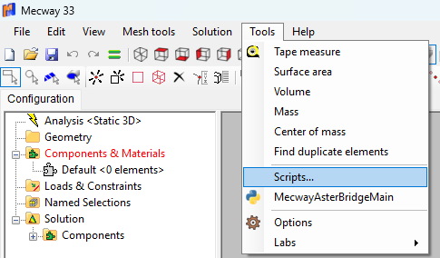
- Create the link tot he script MecwayAsterBridgeMain:
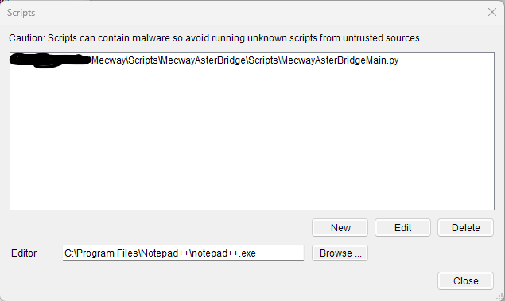
- Go to Tools/MecwayAsterBridgeMain and run the model you want. Read through all the tooltips and help-files to learn how to use it. You can find many test Mecway files in: …\MecwayAsterBridge\TestFiles\Verificatie\modellen
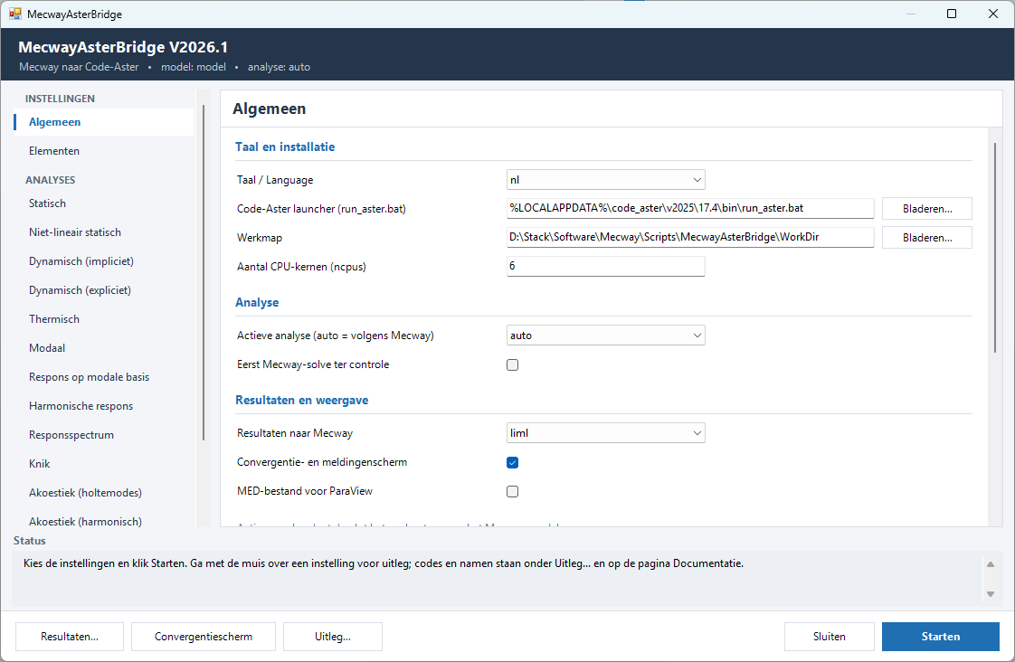

Enjoy! (in case of any suggestions or bugs, let me know via Github)

